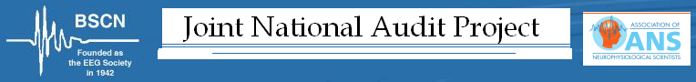

March 2018
Dear Colleague,
We would like to invite you to take part in one of this year’s National Audit Projects, which is an exploration of neurodiagnostic practices for the diagnosis of Motor Neuron Disease (MND)

Rather than collecting departmental data for this, we would like to gain as much information as possible by acquiring data from each UK Consultant Clinical Neurophysiologist.

The rationale for the project was presented at the BSCN conference last year.

Instructions for the project and relevant forms are available on the BSCN website (insert link).

An invite and relevant forms have also been sent to each department via the Audit Leads.

If you have any queries, please contact catherine.pang@nhs.net

On behalf of BSCN | On behalf of ANS
Dr Ming Lai  e mail Ming.Lai@nuth.nhs.uk | Catherine Pang  e mail catherine.pang@nhs.net

